*Word Count: 8,552*

dANIEL cOXON

X00131957

A project report submitted in partial fulfilment of the requirements for ITT Dublin’s Bachelor of Science Degree (Ord.) in IT Management

Project Report

The study, evaluation & comparison of modern website design and development strategies including that of Graphic Mint

Table of Contents

The study, evaluation & comparison of modern website design and development strategies including that of Graphic Mint

**Chapter 1 - Host Company Background and Strategic Objectives** 1

**1.** **Introduction** 1

**2.** **Graphic Mint: History** 1

**3.** **Management Structure and Role of Employee** 2

**3.1.** **Business Hierarchy Diagram** 3

**4.** **Role of I.T in supporting business objectives** 4

**4.1.** **Internal Communication** 4

**4.2.** **Internal Project Management** 6

**4.3.** **Design Software** 6

**4.4.** **Web Development Software** 7

**5.**  **Business Processes & Initiatives** 7

**5.1.** **Graphicmint.com** 7

**5.2.** **UsabilityTesting.ie** 8

**5.3.** **Participants.ie** 8

**5.4.** **UXAcademy.ie** 9

**6.** **Strategic Objectives of Graphic Mint** 9

**Chapter 2 - Critical Evaluation of Work Undertaken at the Host Company** 11

**7.** **Work Undertaken** 11

**7.1.** **Social Media** 11

**7.2.** **Marketing Communications (Marcomms)** 11

**7.3.** **Website Development** 12

**8.** **Critical Evaluation** 13

**Chapter 3 - Mini Project Write-up** 14

**9.** **Introduction** 14

**10.** **Graphic Mint Design Process** 14

**10.1.** **Standardised Process for Design Approach** 15

**10.2.** **Standardised Process for Design Approach: Discussed** 17

**10.3.** **User Centered Design** 19

**11.** **Graphic Mint Development Process** 19

**11.1.** **Structure** 20

**11.2.** **Behaviour/Build** 20

**11.3.** **Style** 22

**12.** **Heuristic Evaluations** 22

**12.1.** **Participants.ie Heuristic Evaluation: Results:** 23

**12.2.** **UsabilityTesting.ie Heuristic Evaluation: Results:** 25

**12.3.** **UXAcademy.ie Heuristic Evaluation: Results:** 27

**12.4.** **graphicmint.com Heuristic Evaluation: Results:** 29

**13.** **Form data from real users:** 31

**14.** **Website Comparisons** 34

**Chapter 4 - Mini Project - Conclusions and Recommendations** 38

**16.** **Project Summary** 38

**17.** **Conclusions** 40

**18.** **Recommendations** 40

**Bibliography:** 42

**Abstract**

This project contains various topics ranging from a detailed discussion on the background and strategic objectives of my work placement Host Company, Graphic Mint, a Critical Evaluation of my work undertaken during my placement and a Mini Project. The aim of the mini project was to explore and evaluate the design process and development strategy used within Graphic Mint. This includes an in-depth discussion on each and a Heuristic Evaluation for all for of Graphic Mint’s websites. The aim of these evaluations was to uncover any areas that could potentially be improved. I also carried out a comparison between Graphic Mint’s main website and two other websites belonging to competing Dublin Design agencies. This comparison brought to light some clear similarities but also some stark contrasts.

# **Chapter 1 - Host Company Background and Strategic Objectives**

# **1. Introduction**

As part of my work placement module I am working in Graphic Mint, an award-winning User Experience Design and Innovation agency based in Dublin City. Graphic Mint are a small business with no more than ten employees working on the team at a time. Since starting my work placement in January there has been staff members finishing their positions and new staff starting every few weeks. From my experience so far that is the nature of the business, it seems to be in a constant state of change and progression. This does seem fitting though as Graphic Mint is an adopter of the Agile Methodology in its entire work ethos.

# **2. Graphic Mint: History**

Graphic Mint was set up in 2008 by Julian Becerra (Director of Strategic Design at Graphic Mint) and Séamus Byrne (Director of User Experience at Graphic Mint). Both Julian and Séamus worked in the UX (User Experience) Design industry in San Francisco prior to making the move to Dublin to set up their business. According to Séamus, UX Design wasn't a very prominent industry in Ireland at the time, as “it was fresh in the world”, so they capitalised on the opportunity to build a business in Dublin City. Graphic Mint began on Camden street in a small office block with only a handful of employees. In the beginning they faced a lot of challenges, as the industry was so new, and found that with their first few clients, education was a huge factor, the actual understanding of what UX Design was caused most of their problems. One of their original goals was to bring UX to the masses but now that Graphic Mint has celebrated their ten-year anniversary in 2018, their goals have somewhat shifted. This is as a result of the growth UX has had over the last decade and the fact that it isn’t such an alien concept to everyone anymore. “Everybody knows what UX is nowadays and what UI is and how it all works, especially because everybody has a mobile phone in their hands” (Julian Becerra, 2018). 2015 was the year they made the move to their current location, Poolbeg Street. With the move came more space and more staff to fill it. This was also the year that Graphic Mint became an an award-winning design agency for the work they undertook for Zarion Software, a company that delivers enterprise software services. The team at Graphic Mint designed and developed enhancements for Zarion Allocate, a work allocation software product utilised by financial supervisors and personnel to ensure their employees are not overloaded. They won the People’s Choice Award for their work at the User Experience Awards in New York City.

# **3. Management Structure and Role of Employee**

As Graphic Mint is a small business, the management structure/hierarchy does not span very deep. Julian Becerra is the Director of Strategic Design and Séamus Byrne is the Director of User Experience. As they own the business they are at the top of the management structure. The rest of the employees follow down the chain. This includes Cathal O’Brien (User Interface Developer), Marc Brophy (UX Designer), Tatsiana Artsemiuk (Visual Designer), Brendan Feeney (UX Designer Apprentice), Aoife Burke (Intern), Dylan Lewis (Intern) and myself, Daniel Coxon (Intern). The following diagram is the hierarchy structure of Graphic Mint.

# **3.1. Business Hierarchy Diagram**

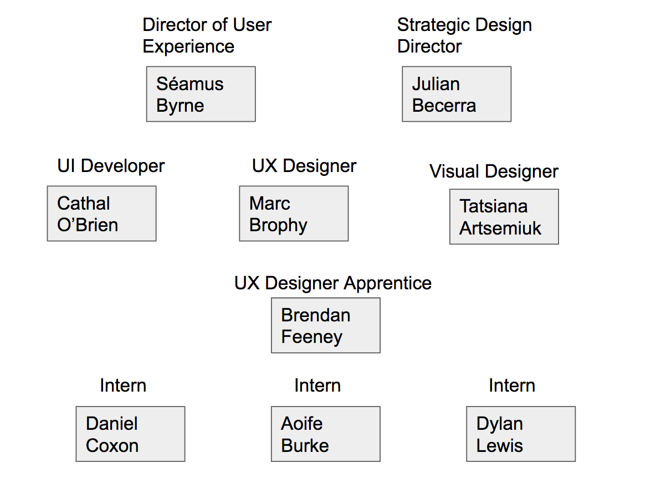

As an intern I have been assigned several roles and responsibilities that support the strategic objectives of Graphic Mint. Cathal O’Brien, Graphic Mint’s UI Developer, has been assigned to me as a mentor during my internship program and I have been working closely with him on multiple projects ranging from strategy projects development. I have recently been tasked with developing the newly redesigned UXAcademy.ie website. It is one of the main projects I have been working closely with Cathal on. He has been teaching me how the websites are developed, using Wordpress and Filezilla, and demonstrating to me how I should be going about the development of UXAcademy.ie. This started with how to interpret the website’s redesign specification given to us by Tatsiana on the design team. Step by step, I was shown the process of how the design is broken into individual elements and how to mark up a printed version of the design on a sheet of paper before even writing any code. This process was very insightful and efficient and made it easier when it came to coding. Another aspect of the business I support through my responsibilities is Social Media and Marketing. I am in charge of the entire schedule for all Social Media platforms including Twitter, Facebook, LinkedIn and Google+. Also, as part part of that role I am a contributor to the Google Adwords account used by Graphic Mint. Advertisements that I write get displayed on Google and have a direct correlation to business enquiries so I feel that this role is of high importance.

# **4. Role of I.T in supporting business objectives**

I.T plays a large role in the everyday running of Graphic Mint. This ranges from communication between staff in the building to larger tasks like web design and development. In this section I will detail all software products used by Graphic Mint to support their business goals and objectives.

# **4.1. Internal Communication**

“Initially when we started up, an old boss of mine said you should check out the Google for Business Suite, that really took a lot of pain out of the decision making around that as it just kept increasing its capability” (Séamus Byrne, 2018). For all internal communications Graphic Mint uses the Google for Business Suite. This includes Calendar, Docs, Drive, Gmail, Hangouts, Sheets, Slides. Google calendar is used daily to schedule internal meetings and presentations. The benefits of this is that Google Calendar gives notifications ten minutes before an event in your calendar is due to take place. Another useful aspect of it is that each staff member can see the calendar of every other staff member. This makes it is easy to see, at a glance, who is busy and when. This eliminates the confusion around when to schedule meetings and presentations depending on people’s availability. Google Docs is used by all staff for writing and collaborating on documents. This collaborative process is extremely efficient and maximises time spent working on project documentation as opposed to trying to send a regular document back and forward between staff members. Google drive is where all collaborative documents, including Sheets, Slides and Docs, are saved. As this is a cloud service, documents of any description can be accessed or shared by anyone who needs them. Gmail is used to send files or important emails between staff members and Hangouts is also used but as a quicker and more informal means of communication between staff members. There are multiple group chats set up within Hangouts. All of which relate to specific ongoing projects or topics of discussion that need a quick back and forth dialogue between multiple people. For example if three of the staff members are working on one project then they can set up a group chat that just contains the people involved. They can then name it the same name as the project they are working on which eliminates people receiving unnecessary messages that don’t apply to them. Google Sheets is used for reporting/spreadsheets and Google Slides is used for presentations. For Docs and Slides there is a custom Graphic Mint template that is used by all staff when they create documents or slides. This template includes the logos, colour scheme and fonts from the style guide of Graphic Mint.

# **4.2. Internal Project Management**

Graphic Mint is a modern, up to date design agency and approaches all projects using the Agile Methodology. “Agile is an iterative project management technique, which is most commonly used in software. The primary goal of this approach is to build an iterative process where teams can quickly respond to change.” (Help.zoho.com, 2018). This means all projects undertaken are ran in sprints. The platform used within the business to monitor projects and their progress is called ‘Zoho Sprints.’ “Zoho Sprints is an online agile project management solution designed to help agile teams plan their project, track their progress, and deliver the appropriate product on time.” (Financesonline.com, 2018). Another aspect of the Agile Methodology implemented into day to day business is daily stand-up meetings. These meetings are carried out every morning at 9:30am and each member of staff is required to bring their laptop, discuss the work they completed the previous day and what they plan to work for the current day. Staff members also present their Zoho Sprints account on the television monitor, using Apple AirPlay, so everyone can see the progress made within their current sprint.

# **4.3. Design Software**

The design team at Graphic Mint use multiple tools day to day to complete their work. One of the main pieces of design software they use is a program called Sketch. Sketch is a digital design application that is exclusively available for MacOS. It is used to create icons and UI prototypes for web and mobile platforms. It is also used by the designers to create other projects such as Graphic Mint’s monthly eZine or, just recently, a video showreel to promote Graphic Mint. The showreel was assembled in Sketch by Dylan, a design intern, and was then imported into Adobe Animate for the animation of the video to be completed. This is an example of the Adobe products used by the design team at Graphic Mint. They also use other Adobe programs such as Photoshop, Lightroom, Premiere Pro and Illustrator.

# **4.4. Web Development Software**

When it comes to developing websites there are multiple software platforms used by the developers. All of Graphic Mint’s websites, including Graphicmint.com, UsabilityTesting.ie, Participants.ie and UXAcademy.ie are all built using Wordpress.com. “WordPress is an online, open source website creation tool” (WordPress?, 2018). An application called Filezilla is also used in conjunction with Wordpress as a server and a FTP (File Transfer Protocol) system. The websites are built using HTML, CSS and PHP.

# **5. Business Processes & Initiatives**

In this section I will detail the various business processes, initiatives and services provided by Graphic Mint to their clients.

# **5.1. Graphicmint.com**

First and foremost, Graphic Mint is the Umbrella Company under which there a three other initiatives. These initiatives being UsabilityTesting.ie (5.2), Participants.ie (5.3) and UXAcademy (5.4), all of which are discussed subsequently in this section. The two main services provided by Graphic Mint are Design centered. The first of which being a User Experience and User Interface Design service to enterprises who work within Software as a Service (SaaS), cloud applications, and digital transformation sectors. This service implements different aspects ranging from User Research, Prototyping, Journey Maps and Responsive Web Design. The end result of this service is to improve the UX of a client’s product before it goes to market. Another Design service provided by Graphic Mint is that of Web, Branding and Customer Experience. The aim of this service is to design and create websites for clients from the ground up. The design team follows User-Centered Design and industry standards to create responsive websites with a contemporary style. This process includes Front-End Development, SEO, Digital Strategy, Style Guides and Content Systems.

# **5.2. UsabilityTesting.ie**

The second initiative run by Graphic Mint is UsabilityTesting.ie. This initiative aims to benchmark, compare and validate design decisions of companies that are building products for the marketplace. As part of this service Graphic Mint will test a client’s website, app or software with members of the public. This way clients get real life insight and feedback from genuine users who give honest opinions about their User Experiences. This service also includes, Planning, Recruiting, Reporting, Testing, Synthesising and Facilitating.

# **5.3. Participants.ie**

The recruiting aspect of UsabilityTesting.ie is done through Graphic Mint’s third initiative, Participants.ie. This website has two functions. The first of which is aimed at members of the public that are looking to participate in Usability Tests. The website contains a form that asks a variety of questions to people who want to sign up. These questions begin with basic things like name, address and age and then progressively become more detailed. This is so the person can be categorised under certain criteria within the database of participants. For example, it asks what type of mobile phone the person uses i.e iPhone, Android, Windows Phone, Blackberry or other. The form also asks the person what their top 3 most used apps are, which devices do they own i.e Laptop, Tablet, Digital Camera, and it also asks them to rate their technical ability out of 5. The person is then added to the database of participants and will be notified by Graphic Mint if ever there is a Usability Test occuring for which they fit the criteria. The user is then rewarded for their time and insight with a voucher valued at €50.

# **5.4. UXAcademy.ie**

Graphic Mint’s fourth and final initiative is UXAcademy.ie. Training programs, Design workshops, conferences and events are hosted by Graphic Mint for Design and Software teams around Dublin. The aim of UXAcademy is to refresh people’s knowledge of User Experience and to bridge the gap between UX Design education and practice in Ireland.

# **6. Strategic Objectives of Graphic Mint**

Graphic Mint’s goals and objectives have changed over the years. In the beginning their focus was on “bringing UX to the masses” (Séamus Byrne, 2018). But now, as it is so widespread, it is more about empowering people working within UX to do it the right way and to make sure there are standards of UX in place. A big part of their objectives is also to help UX teams of one out there who need a lot more support as their reach and capabilities are lacking. There are many small businesses starting out in the UX industry and as UX is a large area, increasing their capability is a huge factor in sustaining their business. Graphic Mint also aims to make things easy to use through the use of User-Centered Design techniques.

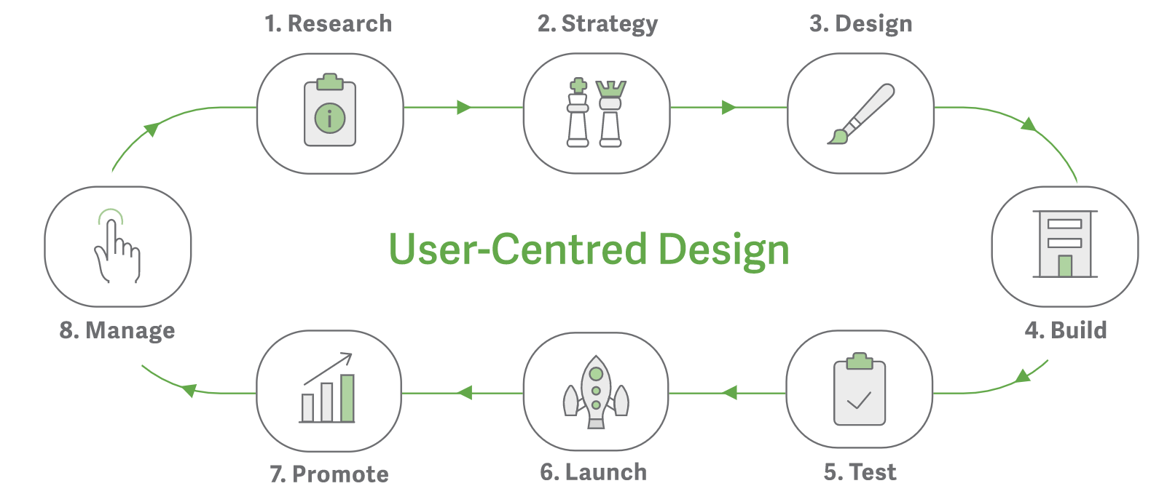

(Graphicmint.com, UCD-Diagram)

The biggest strategic objective of Graphic Mint is to come away from projects having delivered something that's going to be genuinely meaningful. It is important to them not to think of the company’s growth just in terms of profitability but also for it to have a purpose in the world.

# **Chapter 2 - Critical Evaluation of Work Undertaken at the Host Company**

# **7. Work Undertaken**

During my time, thus far, in Graphic Mint, I have been assigned multiple roles and responsibilities. Each will be discussed within this section.

# **7.1. Social Media**

Upon starting my position at Graphic Mint I was told I would be inheriting some responsibilities from their current intern at the time. One of these included the running of the social media schedule for all social channels belonging to Graphic Mint. I was brought up to speed on how it was run and was then walked through how I will be completing the task moving forward. Since then I have been in control of all social media channels including Twitter, Facebook, LinkedIn and Google+. There is a schedule template, that I must follow, which tells me what type of content needs to be posted, on what day of the week and at what time. The content that gets posted ranges from design related articles, sourced online by me, to promotion of Graphic Mint’s various services. Other content includes weekly original blog posts and reposting previous blog posts. The aim of posting interesting articles is to show the personality of Graphic Mint and the aim of the promotion of services and weekly blog posts is to drive traffic to their websites.

# **7.2. Marketing Communications (Marcomms)**

MarComms is a responsibility of mine that goes hand in hand with running the social media schedule. It is a monthly report and presentation that consists of all analytics and statistics gathered from all channels over the course of the month. It is used to compare results of the content that gets posted month over month and helps us to determine what is working and what isn’t. For Twitter, for example, the report records the amount of followers, likes, retweets, comments and mentions we receive over the month. Also the total engagement rate of all posts is recorded. This is the same for Facebook, LinkedIn and Google+. This is then compared to the previous month using a spreadsheet formula to determine whether there is an increase or decrease in the performance of the posts. We can then make a decision on whether to keep the style of posts the same or alter them to be more engaging. This report also includes analytics relating to the performance of all websites ran by Graphic Mint. These include Graphicmint.com, UsabilityTesting.ie, Participants.ie and UXAcademy.ie. The statistics include the amount of new unique visitors, the amount of visitors from specific sources like social media or email referral, and the amount of overall visitors to the site within the month. Bounce rate is also a statistic that is focused on a lot. The bounce rate of any website should be as low as possible. Once this report is filled in entirely I present the findings to Julian, Seamus and Cathal. A discussion then ensues, during the presentation, around the findings and what they mean in regards to what we will alter or keep the same moving forward.

# **7.3. Website Development**

As part of my internship, I am working closely with Graphic Mint’s web developer, Cathal. This has introduced me to new technologies and web development tools such as WordPress and FileZilla. Wordpress is used as the Content Management System and Filezilla is used as the FTP client. I have had multiple tutorial sessions with Cathal where he has shown me how all of Graphic Mint’s websites are built and hosted. I worked with him on the rebuild of UXAcademy.ie which allowed me to put what he had taught me into practice. The build consisted of marking up the design given to us by the design team into page sections so we knew how the pages would be coded. The website was then built using HTML, CSS and PHP. I had never coded in PHP before this so I was interested to learn it.

# **8. Critical Evaluation**

This internship relates mostly to the Web Development modules I have completed in IT Tallaght. There have been instances where the knowledge I have gained from these modules has proved useful to me. For example, during the rebuild of UXAcademy I used my knowledge of HTML and CSS to aid with the website’s development. Another module that I can relate this internship to is Social Media Communications. Upon applying for and starting the internship position, I was not aware that I would be involved with the company’s social media but I do enjoy it. It is an area that I have an interest in. In terms of prospects for the future, this internship has so far shown me what it is like to work within a small business that implements the Agile methodology. It has given me real world experience of the Web Development life cycle and it has taught me aspects of digital marketing that I feel I would like to learn more about.

# **Chapter 3 - Mini Project Write-up**

# **9. Introduction**

This project investigates the design process and development process used within Graphic Mint to design and develop both in-house websites and client projects. As part of this project, I will describe both processes from beginning to end using information gathered from talking with designers and developers in Graphic Mint. Another aspect of this project is four Heuristic Evaluations completed for each of Graphic Mint’s websites including graphicmint.com, UsabilityTesting.ie, UXAcademy.ie and Participants.ie. I will discuss my findings and observations, compare Graphic Mint’s main website, graphicmint.com, to two other websites that work within the same industry in Dublin City. I will also present findings from a user survey I completed that provides insight into the opinions of regular users of the site.

# **10. Graphic Mint Design Process**

The design process at Graphic Mint for all projects, including internal website builds and external client projects, follows a phased approach. Each one consists of steps and touchpoints that are critical to the final product and the User Experience of the client or whomever the end-user may be. I met with Marc, a member of the Design team in Graphic Mint, to gain some insight into this process. He shared with me the phases he follows for all projects he is involved with. In this section I will list the standardised process for all design projects undertaken by Graphic Mint and discuss some of them in detail.

# **10.1. Standardised Process for Design Approach**

1. Research Phase 1: UX / Product Research

* Kick-off meeting
* Key stakeholders interviews
* Product Definition
  + Product Strategy - what it is, what it is not.
  + Product road map - minimum viable product
  + UX Value proposition
* Sharing of analytics
  + Decision on which screen sizes to design for
* Competitive analysis
* Personas
* Scenarios (Version 1)
* Concept Models
* Ecosystem Map
  + Behaviour Variables
  + Cultural Probe

2. Low Fidelity: Paper Prototyping:

* User Requirements
* Information Architecture Map
* High Level layout explorations
* Select 3 layouts max (can be mapped to concept models if applicable)
* Narrow to one layout (1 concept model to proceed with)

3. Research Phase 2: UX Research Updating:

* Scenarios (Version 2)
* User Journey Map

4. Mid-Fidelity: Wireframes / Pixels:

* Define grid style (Bootstrap 4 template), font sizes, font-type (placeholder) and button sizes (consult with visual designer)
* Consistency of interaction design (List all interaction design components)
* Create prototypes in Sketch
* Content Design
* InVision Prototype (only if usability testing / requested by client)

5. Usability Testing:

* Define Participant Profile
* Recruitment
* Define Usability Test type
* User Field Guide for test
* Do the test
* Results
* Iteration on mid-fidelity (resort to low-fidelity if changes are deemed to be major)

6. High-Fidelity: Visual Design:

* Follow Styleguide if client has one already (if applicable)
* Refine consistency of font-size, font-type and button size (if applicable)
* Define Colour usage
* Define Font-type(s)
* Create Icons
* Create illustrations / Photography
* Create Animations (if applicable)
* Create Styleguide for development team

(Standardised Process for Design Approach, 2018)

# **10.2. Standardised Process for Design Approach: Discussed**

The first phase of the process begins with UX / product research. The research that is conducted consists of many different aspects that tie in together to conclude the phase, which in turn, allows the design team to move on to subsequent phases. To commence the journey, a kick-off meeting is held internally. The purpose of which is to discuss the project outline and onboard the team as to what they will be working on for the duration of the project. The general key areas of discussion at a kick-off meeting are “The site’s audience, User’s main scenarios and whether the current site meets User’s needs” (Affairs, 2018). Other areas of discussion include information on the client, who they are, what they do and what they need. Key areas of the project planning are also outlined out in this meeting. These items include a project’s “scope, vision, goals, target audience, content” (Affairs, 2018). Key stakeholder interviews are also held at the early stages of the design process. The purpose of this meeting is to get a clear understanding of the roles of the clients within the company that the product is being designed for. Some typical questions that are generally asked at a key stakeholder interview are, “What is this product or service supposed to be?”, “Who is this product for?” and “What’s your role with respect to this product?”. (Goodwin, 2018).

After these phases, and other subsequent phases are complete, the team then moves onto what’s known in the industry as ‘Paper Prototyping’. “Paper Prototyping is a prototyping method in which paper models are used to simulate computer or web applications.” (Pidoco.com, 2018). At this stage of the design process, the team mocks up paper versions of what the final product will look like. It is an early version of the prototype and it is a time where mistakes should be made so that they aren’t carried over into later phases. Usually, three versions of the prototype are created on paper and a final version is then chosen based on feedback that is received throughout the process.

The ‘Information Architecture’ is also created within this phase. “Information architecture is ... the structure of a system, i.e the way information is grouped, the navigation methods and terminology used within the system.” (Step Two, 2018). The Information Architecture is a key piece to any design as it takes unordered, miscellaneous content and turns it into a navigable site structure that is essential to a good User Experience (UX).

After this phase is complete, important phases such as, defining grid style, detailing the interaction design, creating interactive prototype, carrying out usability tests, deciding on fonts, icons/illustrations and colour scheme are concluded. All of this leads to the body of work created by the design team which is the ‘Styleguide’. This is then handed over to the development team to begin building the product.

# **10.3. User Centered Design**

With all projects undertaken, Graphic mint also follows a well-known industry design methodology called ‘User Centered Design’. This process focuses on gaining a greater understanding of the product’s end user. “We follow a tried and tested User-Centred Design (UCD) process which places the wants, needs and goals of the User at the heart of our Design.” (Graphic Mint, 2018). The steps of the methodology are as follows:

* Research
* Strategy
* Design
* Build
* Test
* Launch
* Promote
* Manage

# **11. Graphic Mint Development Process**

As there is, at the time of writing this, only one developer, Cathal, working in Graphic Mint, I sat down with him to ask him about the development process he follows when building in-house websites and/or client projects. In this section I share the information that I gathered. His process is similar to the designers’ in that it follows a phased approach, although, the majority of the time these phases can overlap and intertwine. The reason for this is that the development process can sometimes take unexpected turns in the wrong direction which provokes the need to revisit some aspects of the build. Problems can arise that cause a setback which means, to avoid this, there needs to be a constant dialogue and open communication between Cathal and the design team. With that being said, here is the usual process that he follows. It is broken up into three main pillars of work:

1. Structure
2. Behaviour/Build
3. Style

# **11.1. Structure**

Within each of these three pillars there are different tasks to be identified and completed. Cathal begins all website builds by reviewing the visual design given to him by the design team. At this stage his aim is to highlight the structure of each page, element by element, and mark out, in terms of html structure, what will be a HTML ‘section’, what will be a HTML ‘row’ and how these will be structured on the page.

# **11.2. Behaviour/Build**

The next point he looks at is the behaviour of pages. This is where he determines what each element on each page will do and how they will interact with other page elements. Cathal stated that this can also be done in the Wireframe stage but this is the stage where it is done the majority of the time. While carrying out all of this, everything is being reviewed and confirmed by the design team to keep everything on the right track. Some questions that Cathal generally asks the designers at this stage are:

* Do you have all fonts and font sizes?
* If an image is full width, is it full width on every screen? If so, what is the cut off point?
* Where are you getting the visual assets from?

These questions are asked to ensure that both the design team and Cathal have a mutual understanding of what it to be done to avoid mistakes in development. Both Cathal and the design team also look at the wireframes together as there is a wireframe for every page but not a visual design for every page. A wireframe is a visual representation of what the end product will look like but at a lower fidelity than a visual design. It doesn’t contain any colours, images, body text or fonts etc. It just represents the structure of a website’s elements and pages.

Once all of this is agreed between the designer and developer, coding can actually begin. Cathal begins his coding process by building a basic html structure of the pages, using HTML comments to mark out where each section will go. This is also where he needs to make a decision on a naming convention for the sections. When all the sections are coded, he explained to me that it is then just essentially a case of filling in the blanks with code. Within each section he adds the code for the content and whatever else is unique to that part of the website. The Content Management System (CMS) that Cathal uses is ‘Wordpress’. This is a back-end Graphical User Interface (GUI) that allows developers to insert and manage content and elements of a website. Cathal reviews all elements on each page of a website during development to determine exactly how they can be assembled and organised. His choice depends on a few factors, how often an element or piece of content will need to be updated or changed in the future or if and element or section can be made into a template to be used dynamically throughout the site. Once again, these are conversations that need to be had with the design team and potentially with stakeholders in the project.

# **11.3. Style**

The final pillar of the process to be undertaken is the styling of the website. For this, Cathal uses CSS to turn unstructured and unstyled content into a responsive and visually accurate representation of the style guide given to him by the design team at the beginning of his process. Once again, within this phase there is a constant open dialogue between himself and the design team to mitigate any errors. When the website is then deemed to be complete by everybody involved, it is reviewed internally before being delivered to the client on the project delivery deadline date.

# **12. Heuristic Evaluations**

As part of this research project I have completed Heuristic Evaluations for all four websites belonging to Graphic Mint, including graphicmint.com, UsabilityTesting.ie, UXAcademy.ie and Participants.ie. Each evaluation consists of multiple categories containing questions ranging from the navigation of the website to the content and visual design. An answer in the form of a numerical value is given to each question which, upon completion, are automatically calculated and given as an an overall evaluation score. The value options for each answer are as follows:

* -1 = Doesn’t comply with the guidelines
* 0 = Somewhat Complies
* 1 = Complies
* N/A = Non Applicable

The categories included in each evaluation are as follows:

* Landing
* Navigation & IA
* Interaction Design (Behaviour)
* Content
* Visual Design
* Forms & Data Entry
* Help, Feedback, Error Tolerance

In this section I will discuss my findings, with the aid of examples, for each website upon completion of the Heuristic Evaluations

# **12.1. Participants.ie Heuristic Evaluation: Results:**

|  |  |  |  |  |
| --- | --- | --- | --- | --- |
| **Summary Results** |  |  |  |  |
|  | Raw score | # Questions | # Answers | Score |
| Dashboard / Landing | 12 | 14 | 14 | **93%** |
| Navigation and Information Architecture | 19 | 25 | 23 | **91%** |
| Interaction Design (Behaviour) | 24 | 40 | 29 | **91%** |
| Forms and Data Entry | 10 | 19 | 16 | **81%** |
| Content | 13 | 20 | 17 | **88%** |
| Visual Design | 30 | 36 | 35 | **93%** |
| Help, Feedback and Error Tolerance | 17 | 34 | 29 | **79%** |
| **Overall score** |  | 188 | 163 | **88%** |

(Heuristic Evaluation, 2018)

**Participants.ie Heuristic Evaluation: Discussion & Observations:**

Participants.ie is the smallest website out of the four sites as it consists of just a single page of information and a sign up form. Its aim is to get Users to sign up to Graphic Mint’s participant database upon reading all of the information provided. Sections on the site include, ‘Looking to Participate?’, ‘Looking for Participants?’ and a sign up form, ‘Sign Up’. As you can see from the results the website received a very high score. This is down to the fact that it is professionally designed and developed to a very high standard. It also conforms to general web usage standards which helps its high evaluation score. However, One section that the site falls down in is the ‘Help, Feedback and Error Tolerance’. Interestingly, I found that this is the case for all four websites.

Examples:

**Question** **Score** **Explanation**

|  |  |  |
| --- | --- | --- |
| It is easy to get help in the right form and at the right time | **-1** | No help given on the site. |

(Heuristic Evaluation, 2018)

|  |  |  |
| --- | --- | --- |
| The site shows users how to do common tasks where appropriate (e.g. with demonstrations of the site's functionality) | **-1** | There are no demonstrations of the site's functionality given to the user. |

(Heuristic Evaluation, 2018)

# **12.2. UsabilityTesting.ie Heuristic Evaluation: Results:**

|  |  |  |  |  |
| --- | --- | --- | --- | --- |
| **Summary Results** |  |  |  |  |
|  | Raw score | # Questions | # Answers | Score |
| Dashboard / Landing | 12 | 14 | 14 | 93% |
| Navigation and Information Architecture | 19 | 25 | 23 | 91% |
| Interaction Design (Behaviour) | 24 | 40 | 30 | 90% |
| Forms and Data Entry | 6 | 19 | 12 | 75% |
| Content | 17 | 20 | 20 | 93% |
| Visual Design | 32 | 36 | 35 | 96% |
| Help, Feedback and Error Tolerance | 18 | 34 | 30 | 80% |
| Overall score |  | 188 | 164 | **88%** |

(Heuristic Evaluation, 2018)

**UsabilityTesting.ie Heuristic Evaluation: Discussion & Observations:**

UsabilityTesting.ie has a very similar look and feel to Participants.ie. A user would be able to tell that they are closely related which is hugely important from a branding perspective. One major difference with this site is that it is substantially deeper than Participants.ie as there is a lot more information within it. Once again this site performed very well in the evaluation and gained an equally high score as its sibling site. This was to be expected as they are so similar in design and functionality. However, there were a variety of things within the ‘Interaction Design (Behaviour)’ section that could be improved with this website.

Examples:

**Question** **Score** **Explanation**

|  |  |  |
| --- | --- | --- |
| The product supports novice and expert users by providing different levels of explanation (e.g. in help and error messages) | **-1** | One explanation for all types of users |

(Heuristic Evaluation, 2018)

|  |  |  |
| --- | --- | --- |
| When a page presents a lot of information, the user can sort and filter the information | **-1** | The content cannot be filtered by the user. |

(Heuristic Evaluation, 2018)

|  |  |  |
| --- | --- | --- |
| The site is free from irrelevant, unnecessary and distracting information | **0** | Home page and Facilities page contains a section with a background image, heading and body text that services no real purpose. |

(Heuristic Evaluation, 2018)

# **12.3. UXAcademy.ie Heuristic Evaluation: Results:**

|  |  |  |  |  |
| --- | --- | --- | --- | --- |
| **Summary Results** |  |  |  |  |
|  | Raw score | # Questions | # Answers | Score |
| Dashboard / Landing | 12 | 14 | 14 | 93% |
| Navigation and Information Architecture | 20 | 25 | 22 | 95% |
| Interaction Design (Behaviour) | 27 | 40 | 30 | 95% |
| Forms and Data Entry | 1 | 19 | 13 | 54% |
| Content | 14 | 20 | 19 | 87% |
| Visual Design | 30 | 36 | 35 | 93% |
| Help, Feedback and Error Tolerance | 14 | 34 | 28 | 75% |
| Overall score |  | 188 | 161 | **85%** |

(Heuristic Evaluation, 2018)

**UXAcademy.ie Heuristic Evaluation: Discussion & Observations:**

UXAcademy.ie is another sibling website to both Participants.ie and UsabilityTesting.ie, so again it is very similar in its design, layout, look and feel. This is to be expected and is executed very well by the design team. This helps to solidify the Users confidence and understanding that all of these websites are related to each other and come from one overarching brand that is Graphic Mint.

The sections of this website that bring its score down are ‘Forms & Data Entry’ and ‘Help, Feedback and Error Tolerance’. This is comparable to the other sites as the form data entry field sections are design very similarly.

Example:

**Question** **Score** **Explanation**

|  |  |  |
| --- | --- | --- |
| Fields on forms contain hints, examples or model answers to demonstrate the expected input | **-1** | Only contains placeholder text that states what information is expected. |

(Heuristic Evaluation, 2018)

**Question** **Score** **Explanation**

|  |  |  |
| --- | --- | --- |
| Pull-down menus, radio buttons and check-boxes are used in preference to text entry fields on forms (i.e. text entry fields are not overused) | **-1** | There are no checkboxes or dropdown menus used, only text entry fields. |

(Heuristic Evaluation, 2018)

**Question** **Score** **Explanation**

|  |  |  |
| --- | --- | --- |
| There is a clear distinction between “required” and “optional” fields on forms | **0** | It is only evident through an error message that is displayed when the user tries to submit the form without entering a value for a required field. |

(Heuristic Evaluation, 2018)

# **12.4. graphicmint.com Heuristic Evaluation: Results:**

|  |  |  |  |  |
| --- | --- | --- | --- | --- |
| **Summary Results** |  |  |  |  |
|  | Raw score | # Questions | # Answers | Score |
| Dashboard / Landing | 10 | 14 | 14 | 86% |
| Navigation and Information Architecture | 20 | 25 | 23 | 93% |
| Interaction Design (Behaviour) | 26 | 40 | 29 | 95% |
| Forms and Data Entry | 5 | 19 | 15 | 67% |
| Content | 18 | 20 | 19 | 97% |
| Visual Design | 32 | 36 | 35 | 96% |
| Help, Feedback and Error Tolerance | 16 | 34 | 30 | 77% |
| Overall score |  | 188 | 165 | 87% |

(Heuristic Evaluation, 2018)

**graphicmint.com Heuristic Evaluation: Discussion & Observations**

Graphicmint.com is the parent brand to all of the websites. It possess attributes that are highly similar to all the other websites, which aids the understanding of Users that, again, it is related, yet it is distinctly different in other ways. For example it uses an overarching colour scheme that incorporates the colours from all of the other sites. This is evident on the landing page just below the hero image. This section contains links to all of the services that Graphic Mint provides. Within the Evaluation, this section stuck out to me in two different scenarios. The first of which was slightly negative and in turn brought down the score of the ‘Landing’ section. Here is an example:

**Question** **Score** **Explanation**

|  |  |  |
| --- | --- | --- |
| Navigation areas on the landing page are not over-formatted and users will not mistake them for adverts | **0** | First time users could potentially mistake the coloured box section on that landing page that displays Graphic Mint's initiatives for ads if they know nothing about the company. This is due to the density of the content and the heavy usage of colour and also the logos of the other websites. E.g. UsabilityTesting.ie |

(Heuristic Evaluation, 2018)

The question asks if navigation areas could be mistaken for ads and I feel as though this section could potentially be mistaken for advertisements. The other scenario where this came up, but in a positive way, was when the question asks if the site makes good use of cross brand promotion.

**Question** **Score** **Explanation**

|  |  |  |
| --- | --- | --- |
| Product pages contain links to similar and complementary products to support cross-selling | **1** | There are links to all of Graphic Mint's other websites throughout the site, such as UsabilityTesting.ie and UXAcademy.ie and Participants.ie. |

(Heuristic Evaluation, 2018)

This section is used effectively to promote their other initiatives but potentially it could be done so in a way that prevents them coming across as advertisements. Perhaps they could be separated out into a card layout. This way the content would be less dense and would clearly distinguish each one as being its own distinct website. Another change that could be made is adding a heading to this section that describes it in such a way that makes it obvious what it is.

The website scored highly for categories such as ‘Content’, ‘Visual Design’ and ‘Interaction Design (Behaviour)’. Once again this is attributed to the fact that the site is designed and developed to an extremely high and professional standard by a team with years of experience. The site ‘complies’ to web design standards that are universally practiced.

# **13. Form data from real users:**

As a means of gathering real world user data on the usability and visual appeal of graphicmint.com, I compiled a list of questions in a google form. I provided a link to graphicmint.com within it and asked Users to browse the site for a few minutes and then answer the questions based on their experiences and initial thoughts.

Below is the list of questions that I posed to the Users.

1. Are you viewing the website on Mobile or Desktop?
2. Is the website visually appealing?
3. Do you like the colour scheme used on the website?
4. Are the photographs used throughout the website to a high enough standard/quality?
5. Is the website easy to navigate? (If no please explain.)

Below are the answers I received from the Users:

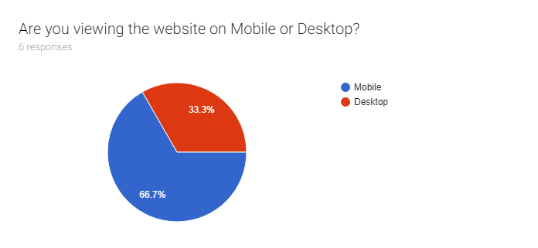

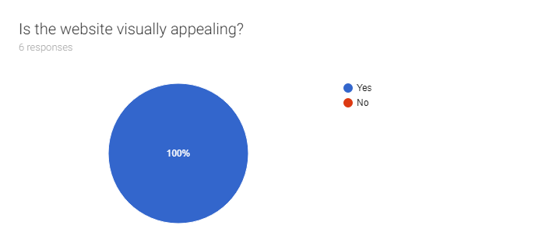

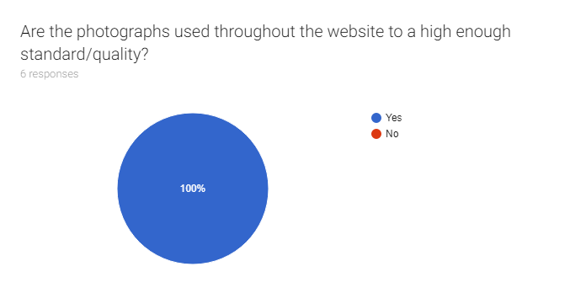

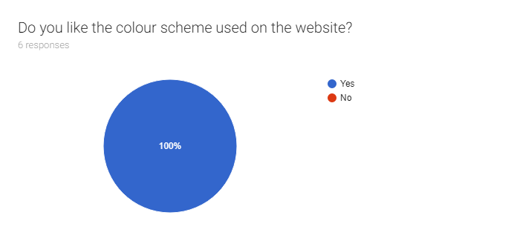

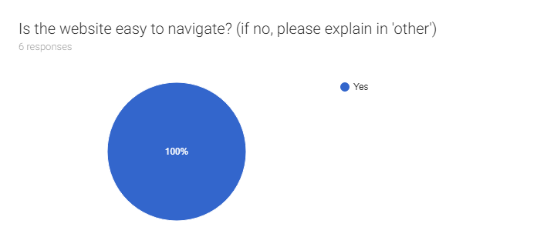

As you can see from the responses, all of the answers are very positive. According to the Users that answered the survey, the site is visually appealing, it has compelling and relevant content including text and imagery and it is easy to navigate. The reason I asked if they were viewing on desktop or mobile was to see, of the people who answered, which platform was it viewed more on as this could influence future development of websites. From this data, mobile viewing was more popular. This type of data could be useful because it shows that there needs to be a greater focus on designing and building websites using a ‘mobile-first’ methodology.

# **14. Website Comparisons**

This project also compares and contrasts graphicmint.com to the websites of two other competing design agencies based in Dublin City. The aim of this comparison is to highlight some key differences between the sites and also areas of similarities. From this, recommendations can be made that could potentially improve graphicmint.com’s aesthetic and/or functionality. The two websites that I will be comparing Graphic Mint’s main site to are V7 (v7.ie) and Xwerx (xwerx.com).

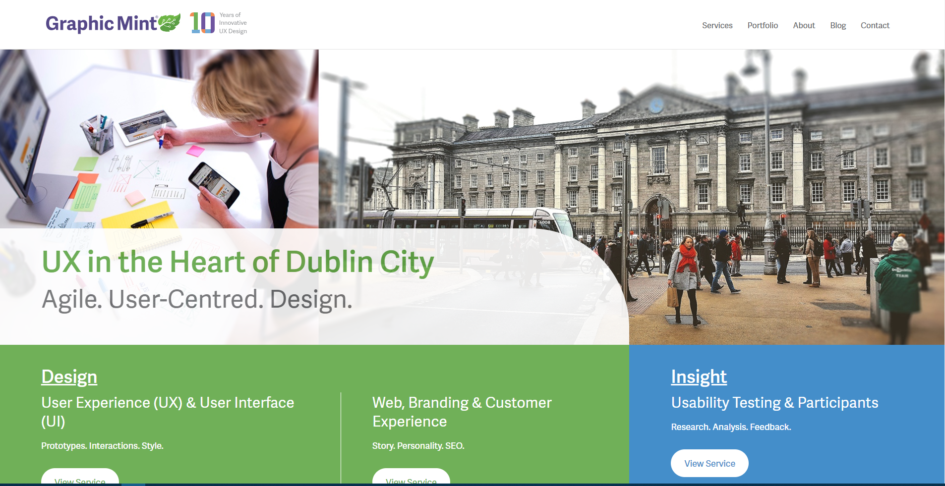(graphicmint.com homepage - above)

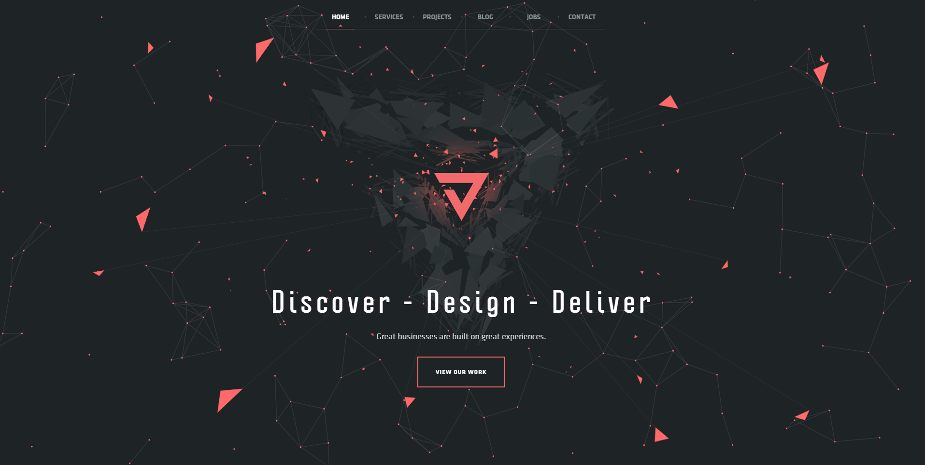

(v7.ie homepage - above)

Beginning with a simple comparison between graphicmint.com’s homepage and v7.ie’s homepage it is immediately evident just how dissimilar these two landing screens are. Differences ranging from colour scheme to layout of content and elements become apparent at first glance. On first opening v7.ie the User is greeted with an animated landing page. The elements comprising the background and surrounding the text are all moving parts that orbit the central focal point which is the company’s logo. This is extremely different to when a User first opens graphicmint.com. In quite the contrast, there are no moving parts or animated elements present and in my opinion this is far superior. In fact, upon first launching v7.ie I found it difficult to figure what the company’s name was as it isn’t shown clearly anywhere on the landing page. Once again this is a large difference compared to graphicmint.com where the company name and logo are very prominently placed in the top left hand corner of the screen. It is also placed on a plain white background which makes the purple and the rest of the colours in the logo stand out and be extremely legible. In my opinion graphicmint.com makes good use of white space and leaves the User with no confusion as to what the name of the company is. This also makes it very easy for Users to find items they might be looking for such as the clickable elements in the navigation bar.

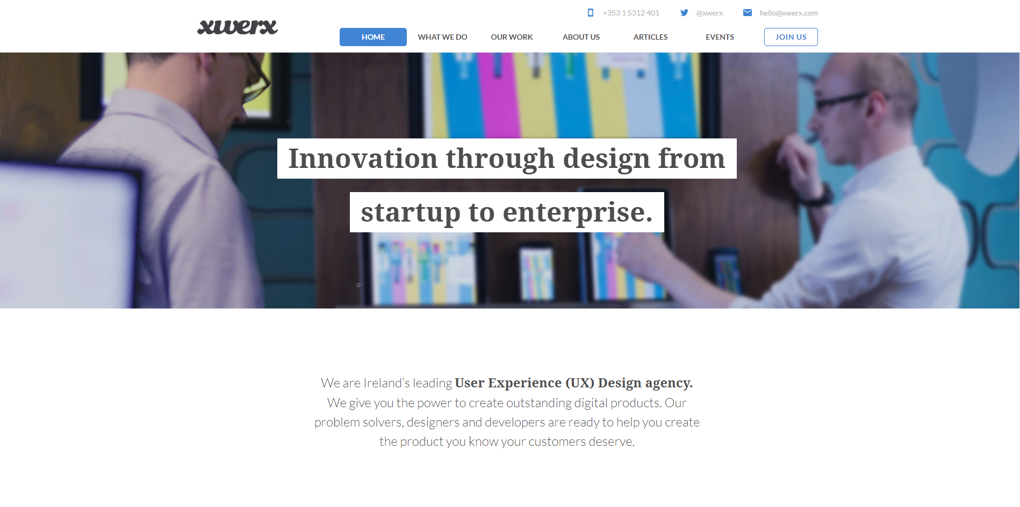

(xwerx.com homepage - above)

When comparing the homescreen of graphicmint.com to that of xwerx.com, it is immediately evident that they share many similarities. In terms of element placement and homescreen structure, similarities include the placement of the company logo, the position of the navigation menu items and the inclusion of a large full width hero image containing a tagline. These are all things that are in complete contrast to v7.ie. One aspect of the navigation bar on xwerx.com that I think works well is the company's contact information that is included in it. This includes their phone number, Twitter handle and email address. I think this is effective as it makes it easy for the User to contact the company quickly if needs be. With all that information being in the footer of graphicmint.com, there is less of a chance that the User will see or use it.

An aspect of v7.ie, when it comes to the UI Design and Interaction & Behaviour of the homepage, is scrolling. When the User first lands on v7.ie there is no way to scroll as all options available to the User live in the navigation. This is very different to xwerx.com and graphicmint.com where there is lots of content and page elements ‘below the fold’. I feel that this landing page is an unnecessary stand-alone page and could easily be incorporated into the next tab which is ‘services’. This is an aspect of graphicmint.com and xwerx.com that I feel enhances the UX when exploring the website. It gives much more of a feeling of openness and freedom to the user as opposed to making them feel like they are enclosed on a page with nowhere to go.

In conclusion, it is clear that these websites share common attributes but also differ in other ways. This exercise was an effective way of gaining an insight and understanding into some of the common design techniques used within modern web design.

# **Chapter 4 - Mini Project - Conclusions and Recommendations**

# **16. Project Summary**

In this section, I will give a detailed summary of the mini project that I completed in conjunction with my host company, Graphic Mint. I decided to carry out this project as it tied in closely with the work I was involved with on a day to day basis during my work placement. I worked closely with Graphic Mint’s design/development team and their four websites, graphicmint.com, UsabilityTesting.ie, UXAcademy.ie and Participants.ie, which are of major importance to the running of the company every day. For this reason, I decided it would be of benefit to myself and the company to evaluate these websites in such a way that could potentially lead to their improvement in areas such as the User Interface (UI) and User Experience (UX). Therefore, I took it upon myself to critically evaluate these websites using a Heuristic Evaluations template supplied to me by Graphic Mint, and compare their main website, graphicmint.com, to two other websites within the same industry here in Dublin City. I also discussed, in detail, my research into Graphic Mint’s design strategy and development process to give an understanding and outline of the lifecycle of their four websites, all the way from their early stages such as paper prototypes, up to fully functioning websites. To gather information on the design lifecycle, I combined knowledge that I gained through my time working within the company alongside the design team, with insight that I gained through talking with Marc, a UX Designer in Graphic Mint. He shared with me the full process that himself and his team follow when designing any sort of UI and UX. Having worked with the company for some time, I have seen this process first hand and have also carried out some stages of it myself whilst working on in-house projects.

The Heuristic Evaluations that I carried out for each website consisted of multiple categories of questions, including ‘Landing’, ‘Navigation & IA’, ‘Interaction Design (Behaviour)’, ‘Content’, ‘Visual Design’, ‘Forms & Data Entry’, ‘Help, Feedback and Error Tolerance’. Each question required a score from the options -1, 0, and 1. The meanings of the scores were ‘Does not comply’, ‘Somewhat Complies’ and ‘Complies’, respectively. A comment for each question was also optional if I felt that an explanation or some reasoning was necessary for the score I had given the question. Once a score had been allocated to every question accordingly, a final score was generated for the entire evaluation. A summary of each section was also given, showing the score it received for each one. The process of completing these evaluations allowed me to explore these websites thoroughly and uncover aspects of the website that I might have otherwise never examined deeply.

As part of this project, I also gathered real User data through the medium of an online form. This data was a clear indication that Graphic Mint’s website delivers a satisfying and high-quality User Experience to the target User.

Carrying out websites comparisons also introduced me to different website designs that are used throughout the industry. I discovered similarities that conform to general web usage and design but also some distinctly different aspects of design that some companies use on their websites. This became evident when examining v7.ie and xwerx.com. These two websites are extremely different in aspects such as structure and visual design. In my comparison, I uncovered that xwerx.com and graphicmint.com are much more similar in design to v7.ie.

# **17. Conclusions**

From carrying out this project, I have gained a deeper understanding and insight into the standards and practices that are adhered to within modern web design and development. I have examined thoroughly and implemented these practices into my own workings during my work placement internship. The conclusions I have come to are that these standards and practices are in place for a reason and are proven to work when delivering a high standard end product and User Experience. It is clear that these standards are recognised and utilised throughout the industry and yield the results that they intend to.

The Heuristic Evaluations have concluded that Graphic Mint’s four websites, graphicmint.com, UsabilityTesting.ie, UXAcademy.ie and Participants.ie, that were designed and developed in-house, meet these standards and deliver a User Experience that is of a very high standard.

Gathering real User data also solidified these conclusions as all of the answers regarding the visual appeal and navigation of graphicmint.com were positive.

# **18. Recommendations**

Upon completion of this project, there are some recommendations that I will make to Graphic Mint and their design team. These recommendations are drawn from the results of my Heuristic Evaluations which uncovered that the majority of the same issues are prevalent across all four sites. This comes down to the fact that the sites share a lot of the same attributes and features to make it clear to their User base that they come from the same family and the overarching ‘Graphic Mint’ company. The recommendations that I am going to make relate to the categories, ‘Interaction Design (Behaviour)’, ‘Forms & Data Entry’, and ‘Help, Feedback and Error Tolerance’.

Some areas that could be addressed include, adding ‘help’ to the websites as there is no help given on any of the websites. ‘Filtering’ content on a page when lots of information is presented. Another aspect of the design that could be addressed is reducing areas of ‘irrelevant, unnecessary and distracting information’.

Although these recommendations are minor, they could potentially help to improve the score on the Heuristic Evaluation and increase the quality of the User Experience. I will discuss these recommendations with the design team and see if they can be implemented into further iterations of their company websites. I feel that this project has been of benefit to myself and the company as it has uncovered areas of potential improvement for the websites and their overall User Experience and quality.

# **Bibliography:**

**Affairs, A. (2018). *Kick-Off Meeting | Usability.gov*. [online] Usability.gov. Available at: https://www.usability.gov/how-to-and-tools/methods/kick-off-meeting.html [Accessed 19 May 2018].**

***Becerra, J, Byrne, S (2018) ‘Interview with Becerra, J, Byrne, S’. Interviewed by D. Coxon. Graphic Mint***

***Financesonline.com. (2018). Zoho Sprints Reviews: Overview, Pricing and Features. [online] Available at: https://reviews.financesonline.com/p/zoho-sprints/#what-is [Accessed 08 Mar. 2018].***

**Goodwin, K. (2018). *The General Stakeholder Interview - Boxes and Arrows*. [online] Boxes and Arrows. Available at: http://boxesandarrows.wpengine.com/?p=3611 [Accessed 21 May 2018].**

**Graphic Mint. (2018). *UX Design Agency | Get To Know Our Story Graphic Mint*. [online] Available at: https://graphicmint.com/about/ [Accessed 16 May 2018].**

***Graphic Mint. (2018). UX Design Agency | UX, UI, Usability Testing & Strategy | Graphic Mint. [online] Available at: https://graphicmint.com/ [Accessed 10 Mar. 2018].***

***Help.zoho.com. (2018). Introduction to scrum. [online] Available at: https://help.zoho.com/portal/kb/articles/agile-introduction [Accessed 11 Mar. 2018].***

**Heuristic Evaluation: Provided by Graphic Mint (2018)**

***Participants.ie. (2018). Earn Rewards for Usability Testing, Anyone Can Do It! - Participants.ie. [online] Available at: https://participants.ie/ [Accessed 10 Mar. 2018].***

**Pidoco.com. (2018). *Pidoco - The Rapid Prototyping Tool*. [online] Available at: https://pidoco.com/en/help/ux/paper-prototype [Accessed 23 May 2018].**

**Standardised Process for Design Approach: Information gathered from meeting with Graphic Mint design team (2018)**

**Step Two. (2018). *What is information architecture?*. [online] Available at: https://www.steptwo.com.au/papers/kmc_whatisinfoarch/ [Accessed 23 May 2018].**

***Usability Testing. (2018). Our Usability Experts can Improve Your Website through User Research - UsabilityTesting.ie. [online] Available at: https://usabilitytesting.ie/ [Accessed 10 Mar. 2018].***

**Usability.gov. (2018). *User-Centered Design Basics | Usability.gov*. [online] Available at: https://www.usability.gov/what-and-why/user-centered-design.html [Accessed 19 May 2018].**

***UX Academy. (2018). UX Training in UX Design, UI Design & Usability Testing - UX Academy. [online] Available at: https://uxacademy.ie/ [Accessed 10 Mar. 2018].***

***WordPress?, W. (2018). What is WordPress? | WordPress 101 Tutorials :: iThemes. [online] Ithemes.com. Available at: https://ithemes.com/tutorials/what-is-wordpress/ [Accessed 09 Mar. 2018].***